**(SSE-21/12/256/3)- DESIGN AND ANALYSIS OF CIRCULAR PATCH ANTENNA GAIN PATTERNAT 2.4 GHz and COMPARE WITH and WITHOUT SLOT**

**PICO:**

**Problem:** Minimum polarization gain

**Intervention:** Improved using substrate material and slot creation in the antenna

**Comparison:** Gain pattern of with and without slot

**Outcome:** Frequency vs Gain pattern (with and without slot)

**INTRODUCTION:**

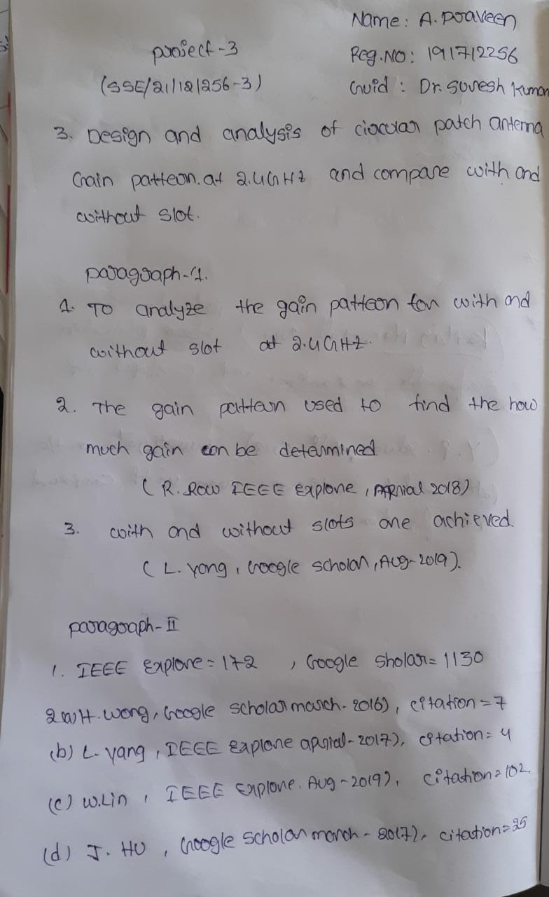

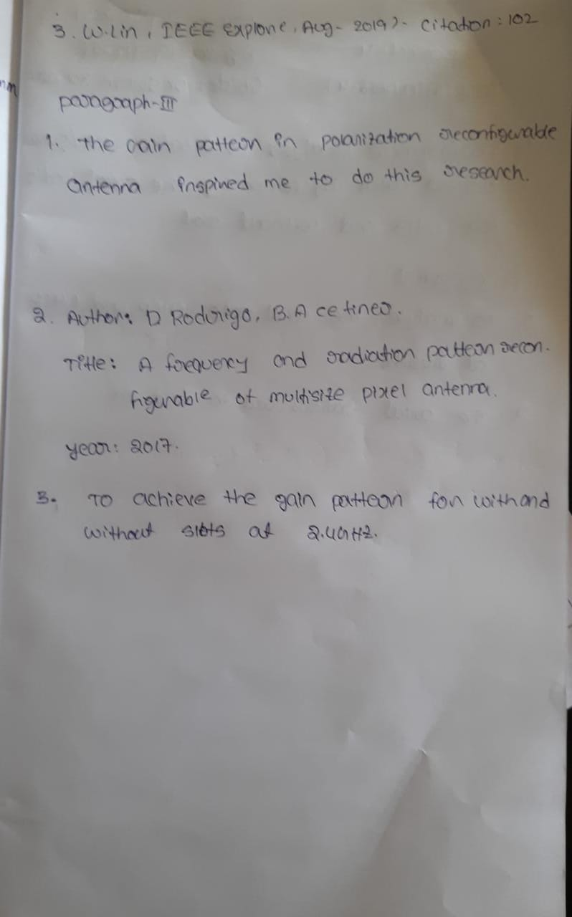**MATERIALS AND METHODS**

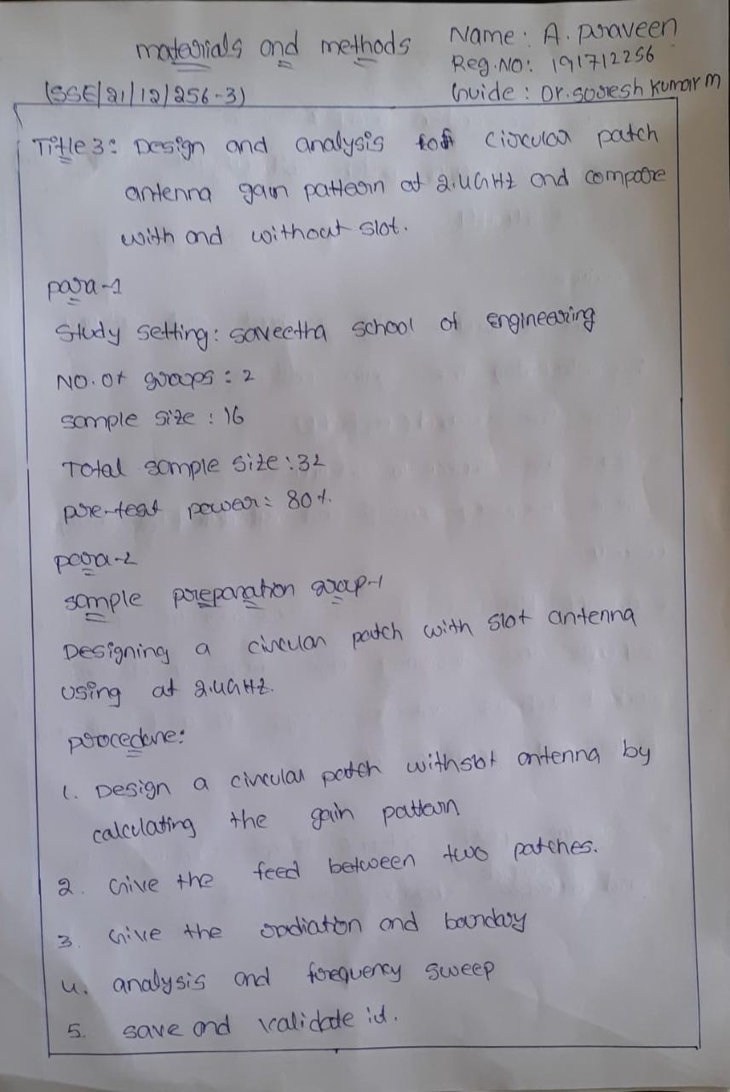

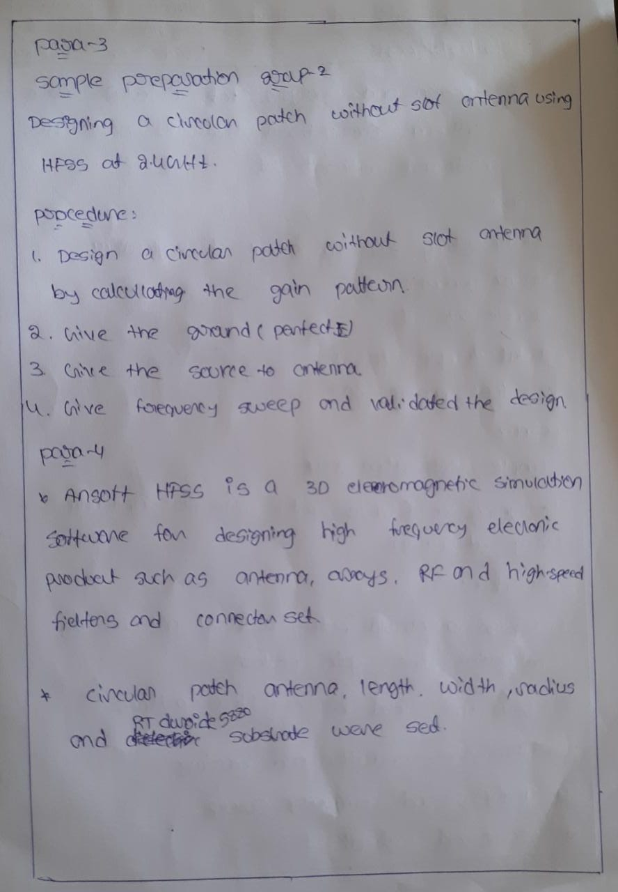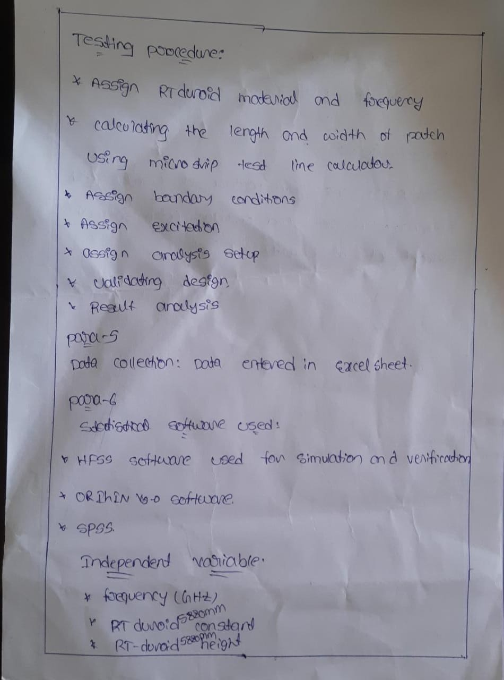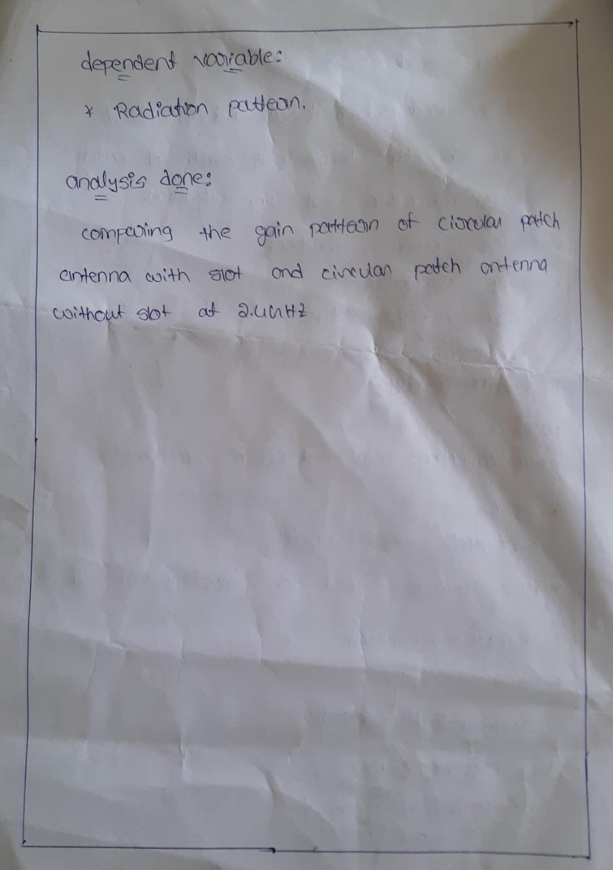

**Data collection: with slot**

|  |  |  |  |  |  |
| --- | --- | --- | --- | --- | --- |
| S.NO | GROUP1 | GAINPHI,PHI=0 | GAINPHI,PHI=90 | GAINPHI,THETA=0 | GAINPHI,THETA=90 |
| 1 | 1 | -45.6154 | -28.4796 | -1.58775 | -15.486 |
| 2 | 1 | -39.5956 | -22.458 | -1.56883 | -15.5071 |
| 3 | 1 | -36.0752 | -18.9345 | -1.53749 | -15.5424 |
| 4 | 1 | -33.5785 | -16.4336 | -1.49401 | -15.5918 |
| 5 | 1 | -31.6431 | -14.4927 | -1.43879 | -15.6556 |
| 6 | 1 | -30.0631 | -12.9061 | -1.37231 | -15.7337 |
| 7 | 1 | -28.7288 | -11.5639 | -1.29515 | -15.8262 |
| 8 | 1 | -27.5748 | -10.4007 | -1.20797 | -15.9333 |
| 9 | 1 | -26.5588 | -9.37446 | -1.11149 | -16.0551 |
| 10 | 1 | -25.6523 | -8.45636 | -1.00652 | -16.1916 |
| 11 | 1 | -24.8348 | -7.62607 | -0.89386 | -16.343 |
| 12 | 1 | -24.0913 | -6.8686 | -0.77439 | -16.5091 |
| 13 | 1 | -23.4105 | -6.17263 | -0.64899 | -16.6899 |
| 14 | 1 | -22.7837 | -5.52946 | -0.51855 | -16.8852 |
| 15 | 1 | -22.2041 | -4.93224 | -0.38397 | -17.0945 |
| 16 | 1 | -21.6661 | -4.37551 | -0.24614 | -17.3172 |

**Data collection: without slot**

|  |  |  |  |  |  |
| --- | --- | --- | --- | --- | --- |
| S.NO | GROUP2 | GAINPHI,PHI=0 | GAINPHI,PHI=90 | GAINPHI,THETA=0 | GAINPHI,THETA=90 |
| 1 | 2 | -37.77 | -23.50 | 2.63 | -22.95 |
| 2 | 2 | -31.75 | -17.48 | 2.65 | -22.89 |
| 3 | 2 | -28.23 | -13.96 | 2.69 | -22.79 |
| 4 | 2 | -25.73 | -11.46 | 2.75 | -22.65 |
| 5 | 2 | -23.79 | -9.51 | 2.81 | -22.46 |
| 6 | 2 | -22.21 | -7.93 | 2.90 | -22.22 |
| 7 | 2 | -20.87 | -6.58 | 2.99 | -21.93 |
| 8 | 2 | -19.71 | -5.42 | 3.10 | -21.57 |
| 9 | 2 | -18.69 | -4.39 | 3.22 | -21.17 |
| 10 | 2 | -17.78 | -3.48 | 3.35 | -20.72 |
| 11 | 2 | -16.96 | -2.65 | 3.49 | -20.22 |
| 12 | 2 | -16.21 | -1.89 | 3.64 | -19.70 |
| 13 | 2 | -15.52 | -1.19 | 3.79 | -19.15 |
| 14 | 2 | -14.89 | -.55 | 3.95 | -18.58 |
| 15 | 2 | -14.31 | .05 | 4.11 | -18.01 |
| 16 | 2 | -13.76 | .60 | 4.28 | -17.43 |

**TABLES AND GRAPHS(SPSS)**

**Group Statistics:**

|  |  |  |  |  |  |
| --- | --- | --- | --- | --- | --- |
|  | group | N | Mean | Std. Deviation | Std. Error Mean |
| gainphi0 | withoutslot | 16 | -21.1357 | 6.83738 | 1.70934 |
| withslot | 16 | -29.0047 | 6.82175 | 1.70544 |
| gainphi90 | withoutslot | 16 | -6.8336 | 6.86547 | 1.71637 |
| withslot | 16 | -11.8128 | 6.86409 | 1.71602 |
| gaintheta0 | withoutslot | 16 | 3.2720 | .54841 | .13710 |
| withslot | 16 | -1.0679 | .44476 | .11119 |
| gaintheta90 | withoutslot | 16 | -20.9029 | 1.85117 | .46279 |
| withslot | 16 | -16.1476 | .59821 | .14955 |

**Independent Samples Test:**

|  |  |  |  |  |  |
| --- | --- | --- | --- | --- | --- |
|  | | Levene's Test for Equality of Variances | | t-test for Equality of Means | |
| F | Sig. | t | df |
|
| gainphi0 | Equal variances assumed | .000 | .993 | 3.259 | 30 |
| Equal variances not assumed |  |  | 3.259 | 30.000 |
| gainphi90 | Equal variances assumed | .000 | .999 | 2.052 | 30 |
| Equal variances not assumed |  |  | 2.052 | 30.000 |
| gaintheta0 | Equal variances assumed | 1.033 | .318 | 24.586 | 30 |
| Equal variances not assumed |  |  | 24.586 | 28.773 |
| gaintheta90 | Equal variances assumed | 20.032 | .000 | -9.777 | 30 |
| Equal variances not assumed |  |  | -9.777 | 18.099 |

Comparison of gain pattern of with and without slot by varying the frequency ranging from 1GHz to 3GHz.there is statistically significant difference in gain pattern of with and without slot. The gain pattern of without slot is higher when compare to with slot.

**BAR CHART COMPARITIVE MEANS:**

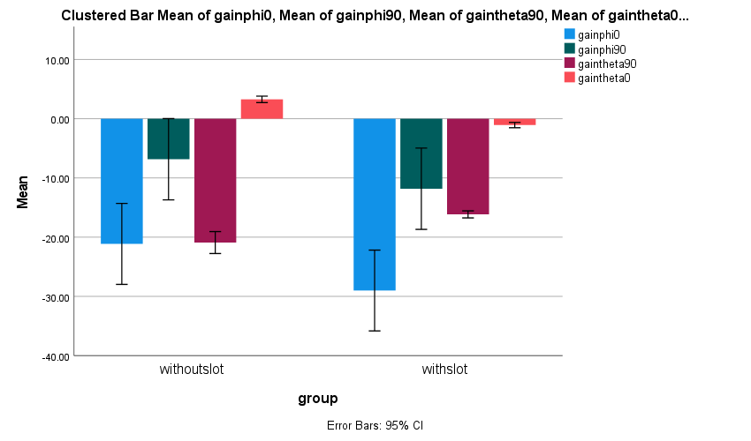

Fig. Bar chart comparing the mean gain pattern of with and without slot by varying the frequency. There is no significance difference between the two groups p>1.00(Independent sample t test).

**WITHOUTSLOT GAIN PATTERN:**

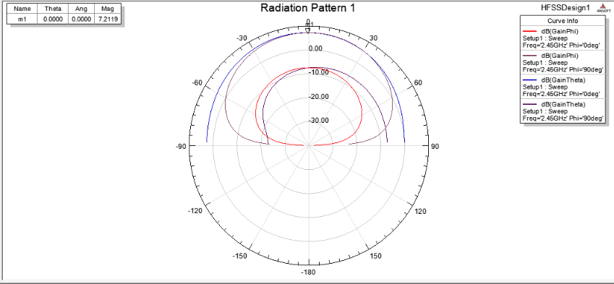

Frequency at 2.45GHz and gain pattern without slot = 7.2119

**WITHSLOT GAINPATTERN:**

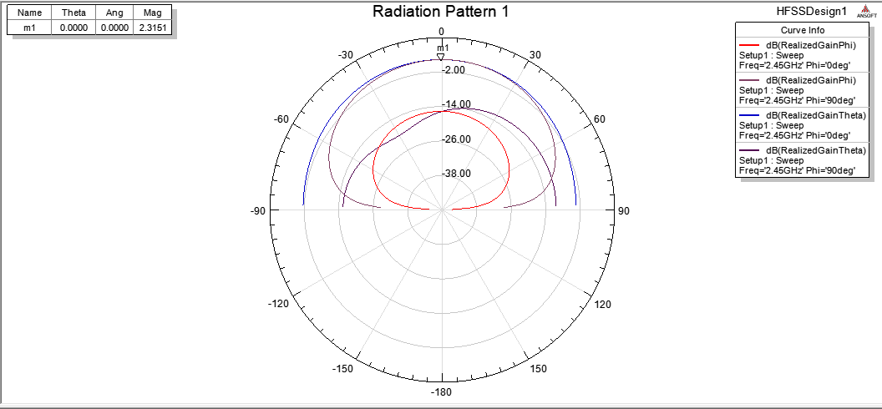

Frequency at 2.45GHz and Reflection coefficient with slot= 2.3151

**DISCUSSION HINTS**

